

Submitted By AIRLINQ INC.

GM Reports Design Document

# PROPRIETARY INFORMATION

The information contained herein is proprietary to Airlinq Inc. Use or disclosure of this document or the information contained herein, for any purpose other than that for which it was furnished is not permitted or it shall not be disclosed or divulged to any third Party without the prior written consent of Airlinq Inc.

# COPYRIGHT NOTICE

This document is copyright © Airlinq Inc. All Rights Reserved. No part of this document, in whole or in part, may be used, reproduced, stored in a retrieval system or transmitted, in any form, or by any means, electronic or otherwise, including photocopying, reprinting, or recording, for any purpose, without the express written permission of Airlinq Inc.

Table of Contents

PROPRIETARY INFORMATION 1

COPYRIGHT NOTICE 1

1. Assumptions 3

2. Phase 1 Reports 5

I. Data Report 5

II. Voice Report 6

III. Successful SMS 6

IV. Mobile Number Reconciliation 7

3. Phase 2 Reports 8

I. Retail Revenue Share feed 8

II. Network Reg Failure feed 8

4. Phase 3 Reports 9

I. Undelivered SMS 9

II. OTA Performance 9

III. APN Billing Details 9

IV. API Transaction Activity Report 9

V. API Transaction Failure Report 9

5. Report Processing Method 11

# Assumptions

* Billing Date for each Report will be “5” for each country
* All the static information for SIM will be taken from GControl
* GControl used for processing the reports should have GM based hierarchy
* Unique Record Identifier will restart for each report from 1 and will be incremented for each report in a csv file.
* GM Country ID for each country:



* Flow IDs agreed with GM:



* MCCMNC Values are:



# Architecture

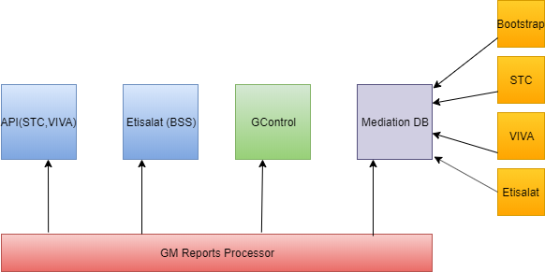

# GM Reports

## Data Report

|  |  |  |
| --- | --- | --- |
| **Data (Packet)** | **Field** | **End Node** |
| Unique Record Identifier |  | Dynamic |
| ICCID |  | Gcontrol |
| MSISDN | *Subscriber (MSISDN) | Mediation |
| IMSI | Subscriber (IMSI) | Mediation |
| Supplier Account ID (default or country account) |  | Gcontrol |
| Billing Cycle Date/Code | Static | Static |
| **Rate/Service/Pricing** Plan (demo/trial plan or non-demo/tial) |  | Gcontrol |
| Origination Date/Time hh:mm:ss (GMT/UTC) | UTC Timestamp | Mediation |
| Data Usage - Raw Total | Bytes Uplink + Bytes Downlink | Mediation |
| Transmit Byte Count | Bytes Uplink | Mediation |
| Receive Byte Count | Bytes Downlink | Mediation |
| Data Usage - Rounded (Billable) | Dynamic | Derived |
| APN | APN | Mediation |
| Device IP Address |  |  |
| Operator Network | Derived | Derived |
| Origination Date/Time (Record Open Time) | UTC Timestamp | Mediation |
| Session Duration (seconds) | Duration | Mediation |
| Record Sequence Number (if multiple records for data session) | Partial CDR Sequence Number | Mediation |
| Call Termination Reason (Data Session Close Cause) | Session Close Cause | Mediation |
| **Rating/Stream** ID (IP range identifier) | Rating Group | Mediation |
| CGI( Cell Global Identifier) |  |  |
| SAI (Service Area Identifier) |  |  |
| RAI (Routing Area Identifier) |  |  |
| TAI (Tracking Area Identity) |  |  |
| ECGI(E-UTRAN CGI) |  |  |
| LAI (Location Area Identifier) |  |  |
| Serving Switch (Serving SGSN) | SGSN/SGW IP Address | Mediation |
| Call Technology Type (2G, 3G, 4G) | RAT | Mediation |
| GGSN IP Address | GGSN/PGW IP Address | Mediation |

## Voice Report

|  |  |  |
| --- | --- | --- |
| **Voice (Successful & Failed)** | **Field** | **End Node** |
| Unique Record Identifier |  | Dynamic |
| ICCID |  | Gcontrol |
| MSISDN | *Subscriber (MSISDN) | Mediation |
| IMSI | Subscriber (IMSI) | Mediation |
| Supplier Account ID (default or country account) |  | Gcontrol |
| Billing Cycle Date/Code | Static | Static |
| Call Direction (MT/MO) | Direction | Mediation |
| **Rate/Service/Pricing** Plan (demo/trial plan or non-demo/trial) |  | Gcontrol |
| Origination Date/Time hh:mm:ss (GMT/UTC) | UTC Timestamp | Mediation |
| Calling Party Number (from) | *Subscriber (MSISDN) | Mediation |
| Called # (to) | *Other Party (MSISDN) | Mediation |
| Answer Duration (Raw) | Duration | Mediation |
| Answer Duration - Rounded (Billable) | Dynamic | Derived |
| Operator Network | Derived | Derived |
| TAP Code (PLMN) | Carrier TADIG Code | Mediation |
| Call Termination Reason (normal, short, dropped, other) |  |  |
| Call Type (Circuit Switched or Packet Switched) | PS/CS | Dynamic |

## Successful SMS

|  |  |  |
| --- | --- | --- |
| **Successful SMS** | **Field** | **End Node** |
| Unique Record Identifier |  | Dynamic |
| ICCID |  | Gcontrol |
| MSISDN | *Subscriber (MSISDN) | Mediation |
| IMSI | Subscriber (IMSI) | Mediation |
| Supplier Account ID (default or country account) |  | Gcontrol |
| Billing Cycle Date/Code | Static | Static |
| Call Direction (MT/MO) | Direction | Mediation |
| **Rate/Service/Pricing** Plan (demo/trial plan or non-demo/tial) |  | Gcontrol |
| Origination Date/Time hh:mm:ss (GMT/UTC) | UTC Timestamp | Mediation |
| Serving Switch (Network Node) |  |  |
| Originating Address (MT) (from) | *Subscriber (MSISDN) | Mediation |
| Destination Address (MO) (to) | *Other Party (MSISDN) | Mediation |
| Operator Network | Derived | Derived |

## Mobile Number Reconciliation

|  |  |  |
| --- | --- | --- |
| **Mobile Number Reconciliation** | **Field** | **End Node** |
| ICCID (active ICCID in the vehicle that day) (*unique identifier for this feed) |  | Gcontrol |
| IMSI (active IMSI in the vehicle that day) |  | Gcontrol |
| MSISDN |  | Gcontrol |
| Supplier Account ID (default or country account) |  | Gcontrol |
| GM SIM State - GM device lifecycle state sent to GT (Device Shipped, UnSoldNewVehicle, Subscribed, Dormat) |  | Derived |
| GT SIM State - inactive, active, suspended, other |  | Gcontrol |
| **Rate/Service/Pricing** Plan (demo/trial plan or non-demo/trial) (sent to GT in API call) |  | Gcontrol |
| Communcation (Roaming) Plan ID |  | Gcontrol |
| Bootstrap ICCID Initial Activation Date (SIM Feed date loaded into Gcontrol) |  | Gcontrol |
| Bootstrap ICCID |  | Gcontrol |

## Monthly Recurring charges

|  |  |  |
| --- | --- | --- |
| **Monthly Recurring charges** | **Field** | **End Node** |
| Unique Record identifer |  | Dynamic |
| ICCID |  | Gcontrol |
| IMSI |  | Gcontrol |
| MSISDN |  | Gcontrol |
| Supplier Account ID (default or country account) |  | Gcontrol |
| Billing Cycle Date/Code |  | Gcontrol |
| Charge Amount (Data) | TOTAL(Data Usage - Rounded (Billable)) for Data | Mediation |
| Charge Amount (SMS) | TOTAL(Successful SMS) for SMS | Mediation |
| Charge Amount (Voice) | TOTAL(Answer Duration - Rounded (Billable)) for VOICE | Mediation |

# BIG Invoice

|  |  |  |  |  |  |
| --- | --- | --- | --- | --- | --- |
| **Field** | **Definition** | **Comment** | **Data Type** | **Max Length / Format** | **Source** |
| Charge Record Type | Indicates the charge type for the record; Each invoice is reported in several record types representing the various types of charges that make up a total invoice; Each invoice reported will include a record for each record type even if the content is 0 for the invoice | See values in Column C of the Big Invoice Report Detail sheet for valid record types | AlphaNumeric | 50 | AMX |
| Account ID | Control Center account identifier | Populated for all record types | Integer | 999999999999999 | AQ |
| Account Name | Name of invoiced account | Populated for all record types | AlphaNumeric | 100 | AQ |
| Operator Account ID | External account ID assigned by the operator | Populated for all record types | AlphaNumeric | 50 | AMX |
| AccountTaxID | Tax ID of the account | Populated for all record types | AlphaNumeric | 25 | AMX |
| Billing Cycle | Billing cycle ID; join to the Billing Cycle Reference table for details | Populated for all record types | Integer | 999999999999999 | AMX |
| Billing Month | The billing cycle month (MMM); if the billing cycle straddles two months, the month containing the end date is used. | Populated for all record types | AlphaNumeric | 9 | AQ |
| Billing Year | The billing cycle year (YYYY); if the billing cycle straddles two years, the year containing the end date is used. | Populated for all record types | Integer | 9999 | AQ |
| Invoice ID | ID of the invoice | Populated for all record types | Integer | 999999999999999 | AMX |
| Currency Code | Currency used by the invoice | Populated for all record types | AlphaNumeric | 3 | AMX |
| Billable Flag | Flag indicating whether the account was billable at the end of the billing cycle | Populated for all record types | AlphaNumeric | 1 | AMX |
| Invoice Date | Date of the invoice | Only populated in header record | DateTime | YYYYMMDDHHMISS | AMX |
| Due Date | Due date of the invoice | Only populated in header record | DateTime | YYYYMMDDHHMISS | AMX |
| Total Subscribers | Number of devices participating in the invoice | Only populated in header record and subscription records | Integer | 999999999999999 | AQ |
| Total Active Subscribers | Number of devices in active subscription terms on the invoice | Only populated in header record and subscription records | Integer | 999999999999999 | AQ |
| Total Active Subscribers Charged in Period | Number of active subscribers charged subscription fees on the invoice; for prepaid and event rate plans, this is the number of subscribers that started their terms | Only populated in header record and subscription records | Integer | 999999999999999 | AQ-CDR |
| Total Volume | Total volume used by all devices on the invoice  (= included+overage+roaming) | Populated for Usage types only | Integer | 999999999999999 | AQ-CDR |
| Total Included Volume Used | Total included volume used by all devices on the invoice | Populated for Usage types only | Integer | 999999999999999 | AQ-CDR |
| Total Overage Volume Used | Total overage volume used by all devices on the invoice in zones not flagged as "Roaming" | Populated for Usage types only | Integer | 999999999999999 | AQ-CDR |
| Total Roaming Volume Used | Total overage volume used by all devices on the invoice in zones flagged as "Roaming" | Populated for Usage types only | Integer | 999999999999999 | AQ-CDR |
| Total Charges | Total charges according to record type; For usage type, = overage charges + roaming charges | Populated for all record types; Total for "Header" record is the sum of "Total Charges" for all other records | Number | 999999999.9999 | AMX |
| Total Overage Charges | Total overage charges incurred by all devices on the invoice in zones not flagged as "Roaming" | Populated for Usage types only | Number | 999999999.9999 | AMX |
| Total Roaming Charges | Total overage charges incurred by all devices on the invoice in zones flagged as "Roaming" | Populated for Usage types only | Number | 999999999.9999 | AMX |

|  |  |  |  |  |
| --- | --- | --- | --- | --- |
| **Columns for Header record** |  |  |  |  |
| **Field** | **Definition** | **Comment** | **Data Type** | **Max Length / Format** |
| Record Type | Will always contain "Header" | This is a single summary record appearing as the first record in the data file | AlphaNumeric | 20 |
| Billing Cycle | Billing cycle ID; join to the Billing Cycle Reference table for details |  | Integer | 999999999999999 |
| Report Date/Time | Date and time the report was generated |  | DateTime | YYYYMMDD HH:MI:SS |

|  |  |  |  |  |
| --- | --- | --- | --- | --- |
| **Columns for Footer record** |  |  |  |  |
| **Field** | **Definition** | **Comment** | **Data Type** | **Max Length / Format** |
| Record Type | Will always contain "Footer" | This is a single summary record appearing as the last record in the data file | AlphaNumeric | 20 |
| Number of Accounts | Count of unique accounts represented in the data |  | Integer | 999999999999999 |
| Number of Records | Number of data records in the data file, excluding the header and footer records |  | Integer | 999999999999999 |

# Report Processing Method

1. Globetouch will generate zip files at midnight UTC and send through sftp to GM folder
2. Each zip file will contain ctl, eot and csv files
3. Csv files will contain reports data for each country
4. Eot file will contain the ctl file name and all the csv files name comma separated
5. For every ctl file row, each csv file name with total number of records in that csv file will come

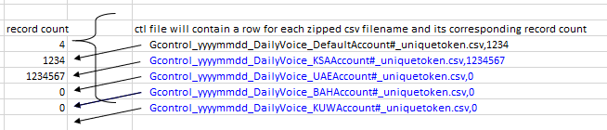

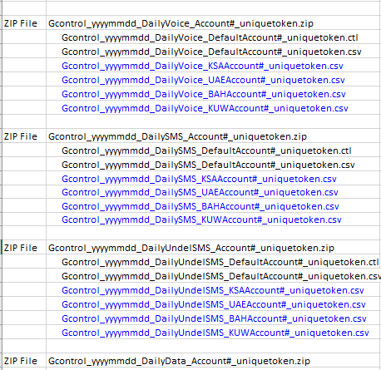



About Airlinq

At Airlinq, we envision a thriving ecosystem of people, businesses, and cities that are related, safe, and efficient.

We strive to enable and empower our customers and partners in defining the present & future of their products and services in a way that presents an open road of possibilities.

Such an objective, drives highly efficient information exchange and decision making supported by insights that have never been available before.

Connected ecosystems of tomorrow will present tremendous monetization opportunities for automakers, connectivity service providers, enterprises and numerous new avenues for customer engagement.

Airlinq Inc.

2200 Camino Ramon Unit B, San Ramon, CA 94583

[www.airlinq.com](http://www.airlinq.com)

info@airlinq.com